**Introduction: Air Temperature Prediction Using IoT Data**

**1. Introduction**

Accurate air temperature prediction is vital for a wide range of applications, including weather forecasting, climate change monitoring, agriculture planning, and smart city infrastructure management. Traditional methods often fail to capture the complex temporal patterns and dependencies present in environmental data. However, the integration of Internet of Things (IoT) sensors has revolutionized data collection, providing continuous and granular environmental data. Leveraging this IoT data with advanced machine learning models can enhance prediction accuracy and provide valuable insights into temperature trends.

**Objective**

The primary objective of this analysis is to utilize machine learning techniques to predict air temperature based on historical IoT sensor data. This involves:

* Conducting **Exploratory Data Analysis (EDA)** to understand the underlying patterns and correlations in the data.
* Applying **Feature Engineering** techniques to extract temporal features (e.g., hour of the day, day of the week) to improve model performance.
* Implementing various **Machine Learning models** including deep learning architectures to accurately forecast air temperature.
* Evaluating model performance using metrics such as **Mean Squared Error (MSE), Root Mean Squared Error (RMSE), Mean Absolute Error (MAE),** and **R² Score.**

**Dataset Overview**

The dataset used in this analysis is sourced from an IoT network that records environmental parameters continuously. It includes the following features:

* **Date-Time**: Timestamps of the recorded measurements, essential for time-series analysis.
* **Temperature**: Measured in degrees Celsius, this is the target variable to be predicted.
* **Humidity**: Relative humidity percentage, which can influence temperature patterns.
* **Other Weather Conditions**: Additional environmental parameters that may include wind speed, pressure, and weather events.

**Detailed View of the Dataset**

* The data is recorded at regular intervals, enabling time-series forecasting.
* It captures both seasonal patterns (e.g., daily and yearly cycles) and short-term fluctuations influenced by local weather events.
* The dataset is suitable for applying both traditional regression models and advanced deep learning models like **Linear Regression** and **DNN**, which can capture complex temporal dependencies.

**Challenges**

* **Handling Missing Data**: IoT sensors may occasionally fail, resulting in gaps in the dataset.
* **Seasonality and Trends**: The data is likely to exhibit seasonality and long-term trends that must be accounted for in the model.
* **Correlation between Features**: Environmental variables such as humidity and temperature are often interdependent, requiring careful feature engineering and selection.

**Link to Dataset**

The dataset is publicly available on **Kaggle** and can be accessed at the following link:

https://www.kaggle.com/datasets/atulanandjha/temperature-readings-iot-devices

**IoT System Design for Air Temperature Prediction Using IoT Data**

The design of an IoT system for air temperature prediction involves the integration of sensors, edge processing, networking, data storage, and machine learning components. The goal is to create a scalable, efficient, and accurate system that collects environmental data, processes it in real-time, and provides predictive insights. This section outlines the theoretical design of an IoT system tailored for the air temperature prediction dataset, addressing the key components necessary for its implementation.

**System Overview:**

The IoT system for air temperature prediction consists of the following key components:

* **Sensors**: To capture environmental parameters such as temperature, humidity, and other relevant weather data.
* **Edge Processing**: For real-time data filtering, preprocessing, and initial analytics.
* **Networking**: To transmit the processed data to cloud storage or a centralized server.
* **Data Storage and Processing**: For managing and processing the incoming data, ensuring scalability and reliability.
* **Machine Learning and Analytics**: To generate predictive insights and models based on historical data.

The **System Architecture Diagram** is provided below, illustrating the complete IoT system design for air temperature prediction.

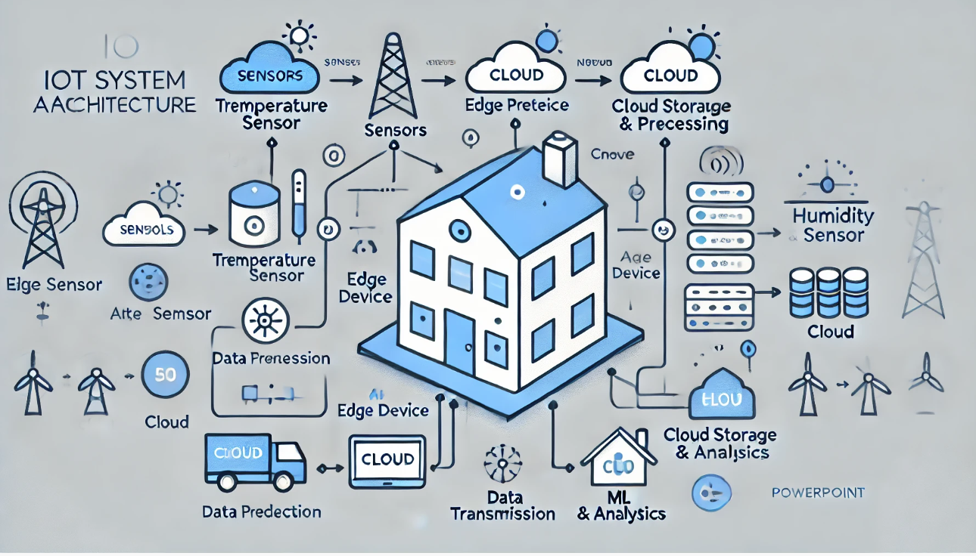

**Explanation of the Minimalist IoT System Architecture for Air Temperature Prediction**

**1. Sensors:**

* **Components:**
  + **Temperature Sensor:**
    - Captures real-time ambient temperature data.
    - Placed strategically to avoid direct sunlight, ensuring accurate measurements.
    - Example: DHT22, BMP280.
  + **Humidity Sensor:**
    - Measures relative humidity, which influences temperature variations.
    - Used to enhance the accuracy of temperature predictions.
    - Example: DHT22, SHT31.
* **Functionality:**
  + Continuously monitors environmental conditions.
  + Sends data to the **Edge Device** for processing.
  + Collects data at fixed intervals (e.g., every minute or hour) to create time-series data.
* **Technical Specifications:**
  + **Accuracy:**
    - Temperature Sensor: ±0.5°C
    - Humidity Sensor: ±2% RH
  + **Communication Protocols:**
    - I2C or SPI for short-range, wired connections.
    - Bluetooth or Zigbee for short-range wireless communication.
  + **Power Consumption:**
    - Low power to support battery-operated devices.
* **Data Flow:**
  + **Step 1:** Sensors capture temperature and humidity data.
  + **Step 2:** Data is transmitted to the **Edge Device** for initial processing.

**2. Edge Device (Edge Processing):**

* **Purpose:**
  + To preprocess raw sensor data locally before transmitting it to the cloud.
  + Reduces data transmission costs and network congestion.
  + Ensures quick anomaly detection and alert generation.
* **Functions:**
  + **Data Filtering:**
    - Removes noise and outliers from raw sensor data.
    - Applies smoothing techniques like moving averages.
  + **Data Aggregation:**
    - Combines data from multiple sensors.
    - Reduces data size while retaining important trends.
  + **Preprocessing:**
    - Normalizes or standardizes data for better ML model performance.
    - Handles missing values to maintain data consistency.
* **Technical Specifications:**
  + **Processor:** ARM Cortex-A72 (e.g., Raspberry Pi 4) or NVIDIA Jetson Nano for advanced processing.
  + **Memory:** 2-4 GB RAM for real-time data processing.
  + **Storage:** Local storage for temporary data retention before cloud transmission.
  + **Operating System:** Linux-based (e.g., Raspbian, Ubuntu Core).
* **Data Flow:**
  + **Step 1:** Receives raw data from **Sensors**.
  + **Step 2:** Filters and preprocesses data.
  + **Step 3:** Transmits cleaned and aggregated data to the **Cloud Storage** using the **Network**.

**3. Network (Data Transfer):**

* **Purpose:**
  + Facilitates reliable and secure data transmission from the **Edge Device** to the **Cloud Storage**.
* **Communication Protocols:**
  + **MQTT (Message Queuing Telemetry Transport):**
    - Lightweight protocol suitable for low-bandwidth IoT applications.
    - Ensures reliable delivery with QoS levels.
  + **HTTP (HyperText Transfer Protocol):**
    - Used for device configuration and data retrieval.
    - Less efficient for continuous data streaming compared to MQTT.
  + **CoAP (Constrained Application Protocol):**
    - Optimized for constrained devices and networks.
    - Supports UDP for low-latency communication.
* **Connectivity Options:**
  + **Wi-Fi (802.11ac):**
    - Suitable for urban and semi-urban areas with reliable infrastructure.
  + **LoRa (Long Range Radio):**
    - Ideal for remote locations due to long-range, low-power communication.
    - Supports up to 15 km range in rural areas.
  + **4G/LTE:**
    - Acts as a backup option for areas without Wi-Fi or LoRa connectivity.
    - Ensures consistent data transmission even in mobile environments.
* **Security Measures:**
  + **TLS (Transport Layer Security):**
    - Encrypts data during transmission for secure communication.
  + **VPN (Virtual Private Network):**
    - Provides an additional layer of security for data transmission.
* **Data Flow:**
  + **Step 1:** Transmits pre-processed data from **Edge Device**.
  + **Step 2:** Sends data securely to the **Cloud Storage**.

**4. Cloud Storage (Cloud Storage & Processing):**

* **Purpose:**
  + Centralized storage and processing of incoming sensor data.
  + Ensures scalability, reliability, and real-time data access.
* **Storage Solutions:**
  + **Time-Series Database (TSDB):**
    - Optimized for storing timestamped data (e.g., InfluxDB, TimescaleDB).
    - Supports real-time querying and analytics.
  + **Data Lake:**
    - Stores raw, processed, and aggregated data for historical analysis.
    - Suitable for batch processing and model training.
* **Data Processing Frameworks:**
  + **Real-Time Processing:**
    - Utilizes tools like Apache Kafka and Spark Streaming.
    - Supports real-time anomaly detection and alert generation.
  + **Batch Processing:**
    - Analyzes historical data trends for model retraining.
    - Provides insights into long-term temperature patterns.
* **Scalability and Availability:**
  + **Auto-scaling:** Automatically adjusts computing resources based on data volume.
  + **Load Balancing:** Ensures even distribution of data processing loads.
  + **Redundancy:** Multiple data centers for high availability and disaster recovery.
* **Security and Compliance:**
  + **Data Encryption:** Ensures data security at rest and in transit.
  + **Access Control:** Role-based access control for data privacy.
  + **Compliance:** Meets regulatory standards (e.g., GDPR, CCPA).
* **Data Flow:**
  + **Step 1:** Stores data from **Edge Device**.
  + **Step 2:** Feeds data to **ML & Analytics** for predictive modeling.

**5. ML & Analytics (Prediction):**

* **Purpose:**
  + Utilizes advanced machine learning models for accurate air temperature prediction.
  + Generates real-time insights and alerts for proactive decision-making.
* **Models Used:**
  + 1. **Traditional ML Model:** Linear Regression - For time series prediction of indoor temperature.
    2. **Deep Learning Model:** DNN Classifier - To classify indoor vs. outdoor temperature readings.
* **Insight Generation:**
  + **Real-Time Prediction:**
    - Predicts short-term temperature changes and anomalies.
  + **Historical Analysis:**
    - Analyzes long-term temperature trends and patterns.
  + **Dashboard Integration:**
    - Displays real-time monitoring, alerts, and predictive analytics.
* **Deployment and Monitoring:**
  + **Microservices Architecture:** Ensures scalability and fault tolerance.
  + **Model Monitoring:** Tracks model accuracy and performance.
  + **Continuous Integration/Continuous Deployment (CI/CD):** Enables seamless model updates.
* **Data Flow:**
  + **Step 1:** Receives data from **Cloud Storage**.
  + **Step 2:** Performs real-time and batch predictions.
  + **Step 3:** Displays insights on dashboards for decision-making.

**Summary:**

* This minimalist architecture provides a complete flow from data collection at the sensor level to advanced analytics and insights.
* It leverages Edge Processing for low-latency anomaly detection and Cloud Infrastructure for scalability and reliability.
* Advanced ML models enhance prediction accuracy, making it ideal for weather forecasting, agriculture management, and smart city infrastructure.
* The design is highly scalable, flexible, and secure, ensuring reliable performance in diverse environmental monitoring scenarios.